Specifications
  - MIS-RMe-0023 Enable archiving of blanket purchase order lines
Version 1.0

Customer: | MIAS
Project: | Transfer of Y customizations to X
proALPHA version: | 9.3
proALPHA Installation(s): | DE+HU
GUI language: | German
Author: | Frédéric Probst
Created on: | 26.03.2024
Last change on: | 26.03.2024
Contact Customer:

This document describes a modification or expansion of the standard software proALPHA and has been checked by the customer. The functional design in chapters 2 - 4 is hereby released for technical specification and costing in compliance with the requirements in section "Final Provisions":

......................................................
Date and Signature of Customer

Contents
1. [UPDATE THE TABLE] 3
1.1 [UPDATE THE TABLE] 3
1.2 [UPDATE THE TABLE] 3
1.3 [UPDATE THE TABLE] 3
1.4 [UPDATE THE TABLE] 3
2. [UPDATE THE TABLE] 4
2.1 [UPDATE THE TABLE] 4
2.2 [UPDATE THE TABLE] 4
2.2.1 [UPDATE THE TABLE] 4
2.3 [UPDATE THE TABLE] 4
3. [UPDATE THE TABLE] 5
3.1 [UPDATE THE TABLE] 5
3.2 [UPDATE THE TABLE] 5
4. [UPDATE THE TABLE] 7
4.1 [UPDATE THE TABLE] 7
4.2 [UPDATE THE TABLE] 7
4.3 [UPDATE THE TABLE] 7
5. [UPDATE THE TABLE] 8
5.1 [UPDATE THE TABLE] 8
5.1.1 [UPDATE THE TABLE] 8
5.1.2 [UPDATE THE TABLE] 8
5.1.3 [UPDATE THE TABLE] 8
6. [UPDATE THE TABLE] 9
7. [UPDATE THE TABLE] 10
7.1 [UPDATE THE TABLE] 10
7.2 [UPDATE THE TABLE] 10
8. [UPDATE THE TABLE] 11

Requirements

References
CR MIS-RMe-0023
Our customer Mias already has a Y modification in their current version 6.1g of proALPHA. This functionality has to be developed anew for their upgrade to 9.3.

Summary and Objectives
In the proALPHA standard version, it is only possible to archive blanket purchase orders completely if they have been fulfilled. MIAS wants a function with which individual blanket lines from a blanket order can also be archived.

Description of requirements

A Tools / Archiving function can be added to the Blanket Purchase Order Lines program.
This new function is only enabled if the respective line is in edit mode and the header of the document has not been archived.
เพิ่มฟังก์ชันเครื่องมือ/การเก็บถาวรลงในโปรแกรมรายการสั่งซื้อแบบเหมาจ่ายได้ ฟังก์ชันใหม่นี้จะใช้งานได้ก็ต่อเมื่อรายการนั้นอยู่ในโหมดแก้ไข และส่วนหัวของเอกสารยังไม่ได้ถูกเก็บถาวร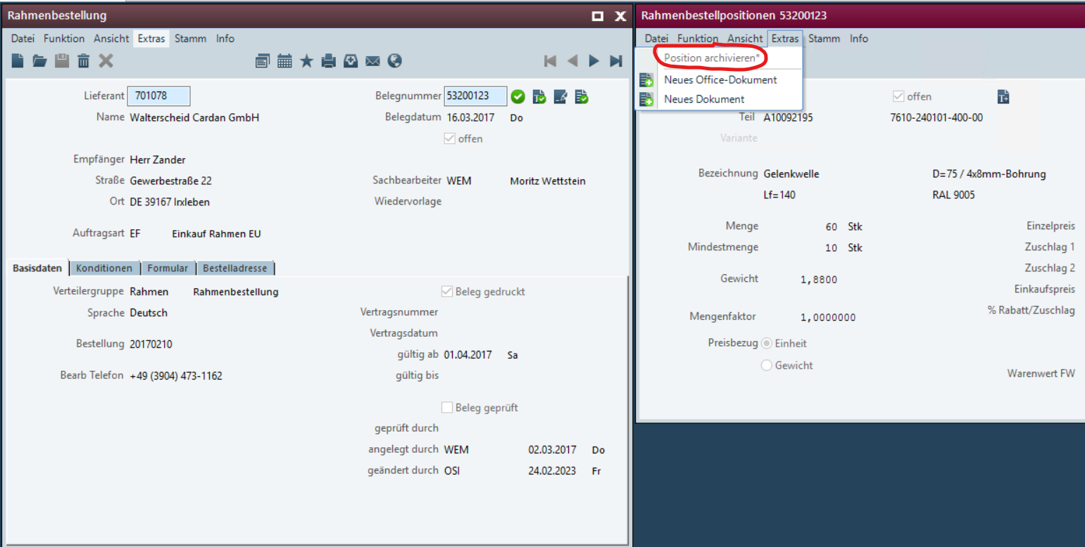

When the program is called, a reference message is displayed to indicate that the task is irreversible and that no purchase orders are entered with reference to this line anymore
เมื่อเรียกใช้โปรแกรม ระบบจะแสดงข้อความอ้างอิงเพื่อระบุว่างานนี้ไม่สามารถย้อนกลับได้ และจะไม่มีการบันทึกใบสั่งซื้อใดๆ ที่อ้างอิงถึงบรรทัดนี้อีกต่อไป
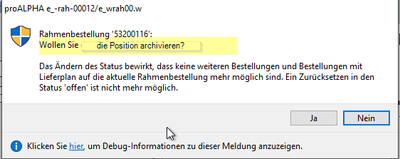

When the line is archived, the confirmation message below is displayed.
เมื่อทำการบันทึกข้อมูลแล้ว ระบบจะแสดงข้อความยืนยัน
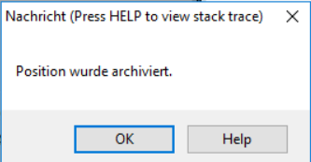

After the line has been archived, the "Open" check box has been removed
หลังจากที่บรรทัดนั้นถูกเก็บถาวรแล้ว ช่องทำเครื่องหมาย "เปิด" จะถูกลบออก
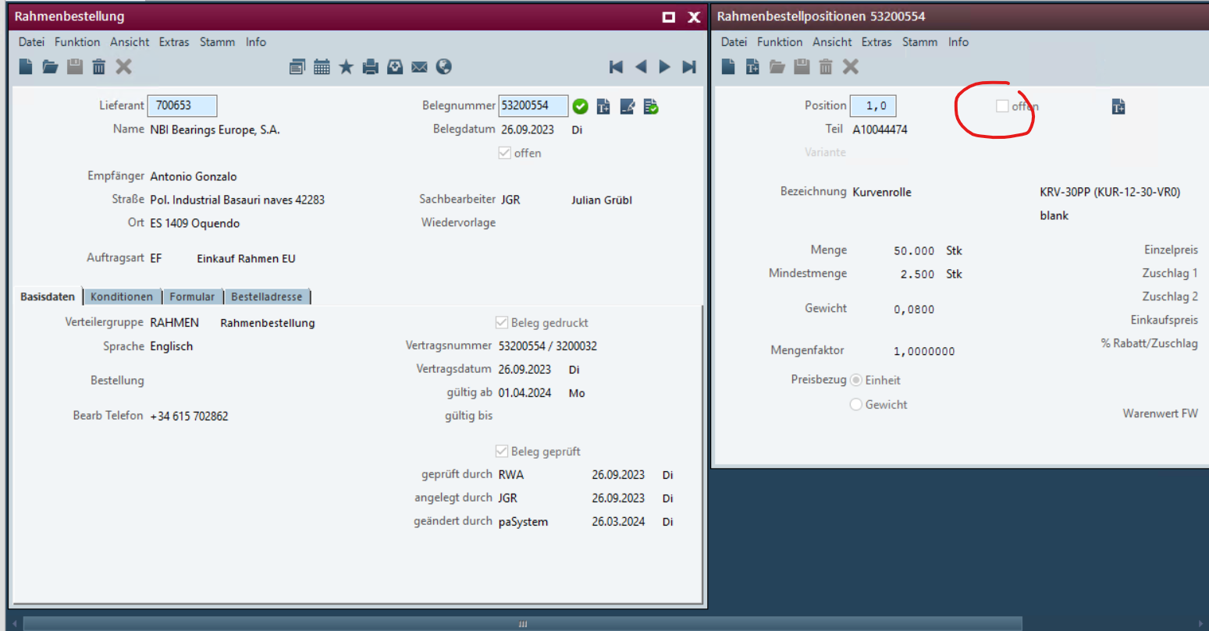

Requirements Glossary (Terminology)

Term | Explanation
Table 1Requirements Glossary

Functional design

Summary of the Solution

Description of the solution

<Template for Section>

Business Logic & GUI

Data Model

Output

Differentiation
The customization refers to the tables, fields and programs mentioned.
These specifications do not automatically add functional extensions to the modules of the proALPHA environment, such as the DMS, Analyzer, reports, and forms. The proALPHA Help is not automatically extended either.
Changes to adjacent modules/programs must be described and defined in the specifications sheet.

Test cases
The specified test cases map the customization described here and are the basis for the acceptance of the software.

<Title of the test case>
Pt | Explanation | Expected result | Test data
 | 1- Create a blanket purchase order with two lines.  2- Create a purchase order with reference to the second line.  3- Use the new archiving function for the first line.  4- Use the new archiving function for the second line.  5- Use the old archiving function for the header line. | 3- the first line has been archived  4- the second line is archived but not the header  5- The header has been archived
 | Test result (incl. screenshots)
 | 1- Create a blanket purchase order with two lines.  2- Use the new archiving function for the first line.  3- Use the old archiving function for the header | 2- The first line has been archived  3- the header and the second line have been archived
 | Test result (incl. screenshots)
 | Test result (incl. screenshots)

<Title of the test case>
Pt | Explanation | Expected result | Test data
 | Test result (incl. screenshots)
 | Test result (incl. screenshots)
 | Test result (incl. screenshots)

Requirements

Technical Requirements
The use of proALPHA functionalities outside the concurrent user model (connection of external systems, background processing) requires the licensing of so-called software services.
"Use of proALPHA functionalities" refers to any use or access to the proALPHA infrastructure, e.g.
- Writing to proALPHA data structures
- Calling proALPHA classes and other business logic
- Opening proALPHA Services
The implementation described in the specifications therefore requires the following software services:
- <Please list services here, otherwise delete section>
- ...

Organizational Requirements

Notes about the go-live

Technical Design

<Template for Section>

GUI

Business Logic

Data Model

Final Provisions
These specifications form the basis for customer-specific extensions of the standard software proALPHA®.
The customer-specific extensions only cover the area defined in this specification sheet. Functionality beyond this scope is not provided.
Unless explicitly agreed otherwise, the customer-specific extensions are only created in German: no programs, program parts or data are translated into other languages. This also applies to the languages supported by ^{proALPHA®} in the standard version.
The customer-specific extensions are thoroughly tested before they are delivered. However, for technical reasons, it is not possible to perform the test under the same conditions and with the same data as the customer will use. It is therefore recommended to carefully check the functions in the real system environment after their delivery.
The Customer is aware that the transfer of the functions defined in this specification sheet to new versions of proALPHA® may require deviations in the display details or handling. This specification sheet also remains valid in this case, provided that there is a maintenance agreement for the customer-specific extensions defined in this specification sheet and no changes to the functionality have to be agreed on.
This specification sheet documents the customer-specific extensions. No other documentation beyond the specifications contained in this specification sheet is to be provided. Questions about customer-specific extensions are received and forwarded by the hotline.
By signing on page 1, you confirm:
that the specification sheet is accepted in this version and becomes part of the contract,
that this specification sheet defines the functional scope of the software to be created and that there are no side agreements regarding the functionality.

Annex

Table of Figures
No entries could be found for a table of figures.

Table of tables
TOC \h \z \c "Tabelle" No entries could be found for a table of figures.

Change History
Doc. -  Version | Date | Specialist | Initiator | Chapter | Explanation
1.0 |  | Frédéric Probst |  | All | Initial new entry

